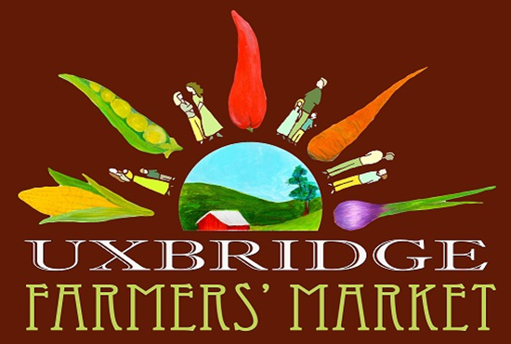 | SPONSOR  REGISTRATION FORM  2023 Sponsorship Fee $250/date

Sponsor Name
Sponsor Website
Sponsor FaceBook page name handle | @
Sponsor Instagram name handle | @
Contact Name/tel
Contact Email
Week requested*
Will be onsite | YES/NO
Will provide flyers for display | YES/NO
*Dates will be filled on a first come first serve basis and confirmed upon receipt of payment.

- Sponsor will be mentioned in two social media posts (Facebook and Instagram) leading up to the desired sponsorship weekend and tagged.
If a specific photo to be used for media posting, please provide a week in advance.
- Cards, flyers, and banners (if provided) will be displayed at the community tent.
- One 10'x10' spot for Sponsor that wish to attend the market will be included.
(Note: tent/weights, table, and chairs must be provided by the Sponsor)
- If any samples/giveaways are planned, preferably first sourced from the UFM Vendors.

Sponsor: _____________________________________ Date: ____________________

UFM Representative: ___________________________ Date:_____________________

Cheque payable to: Uxbridge Farmers Market and give to Lisa Cooper; or e-Transfer to: ufmpayment@gmail.com as soon as a date is chosen to secure it.

